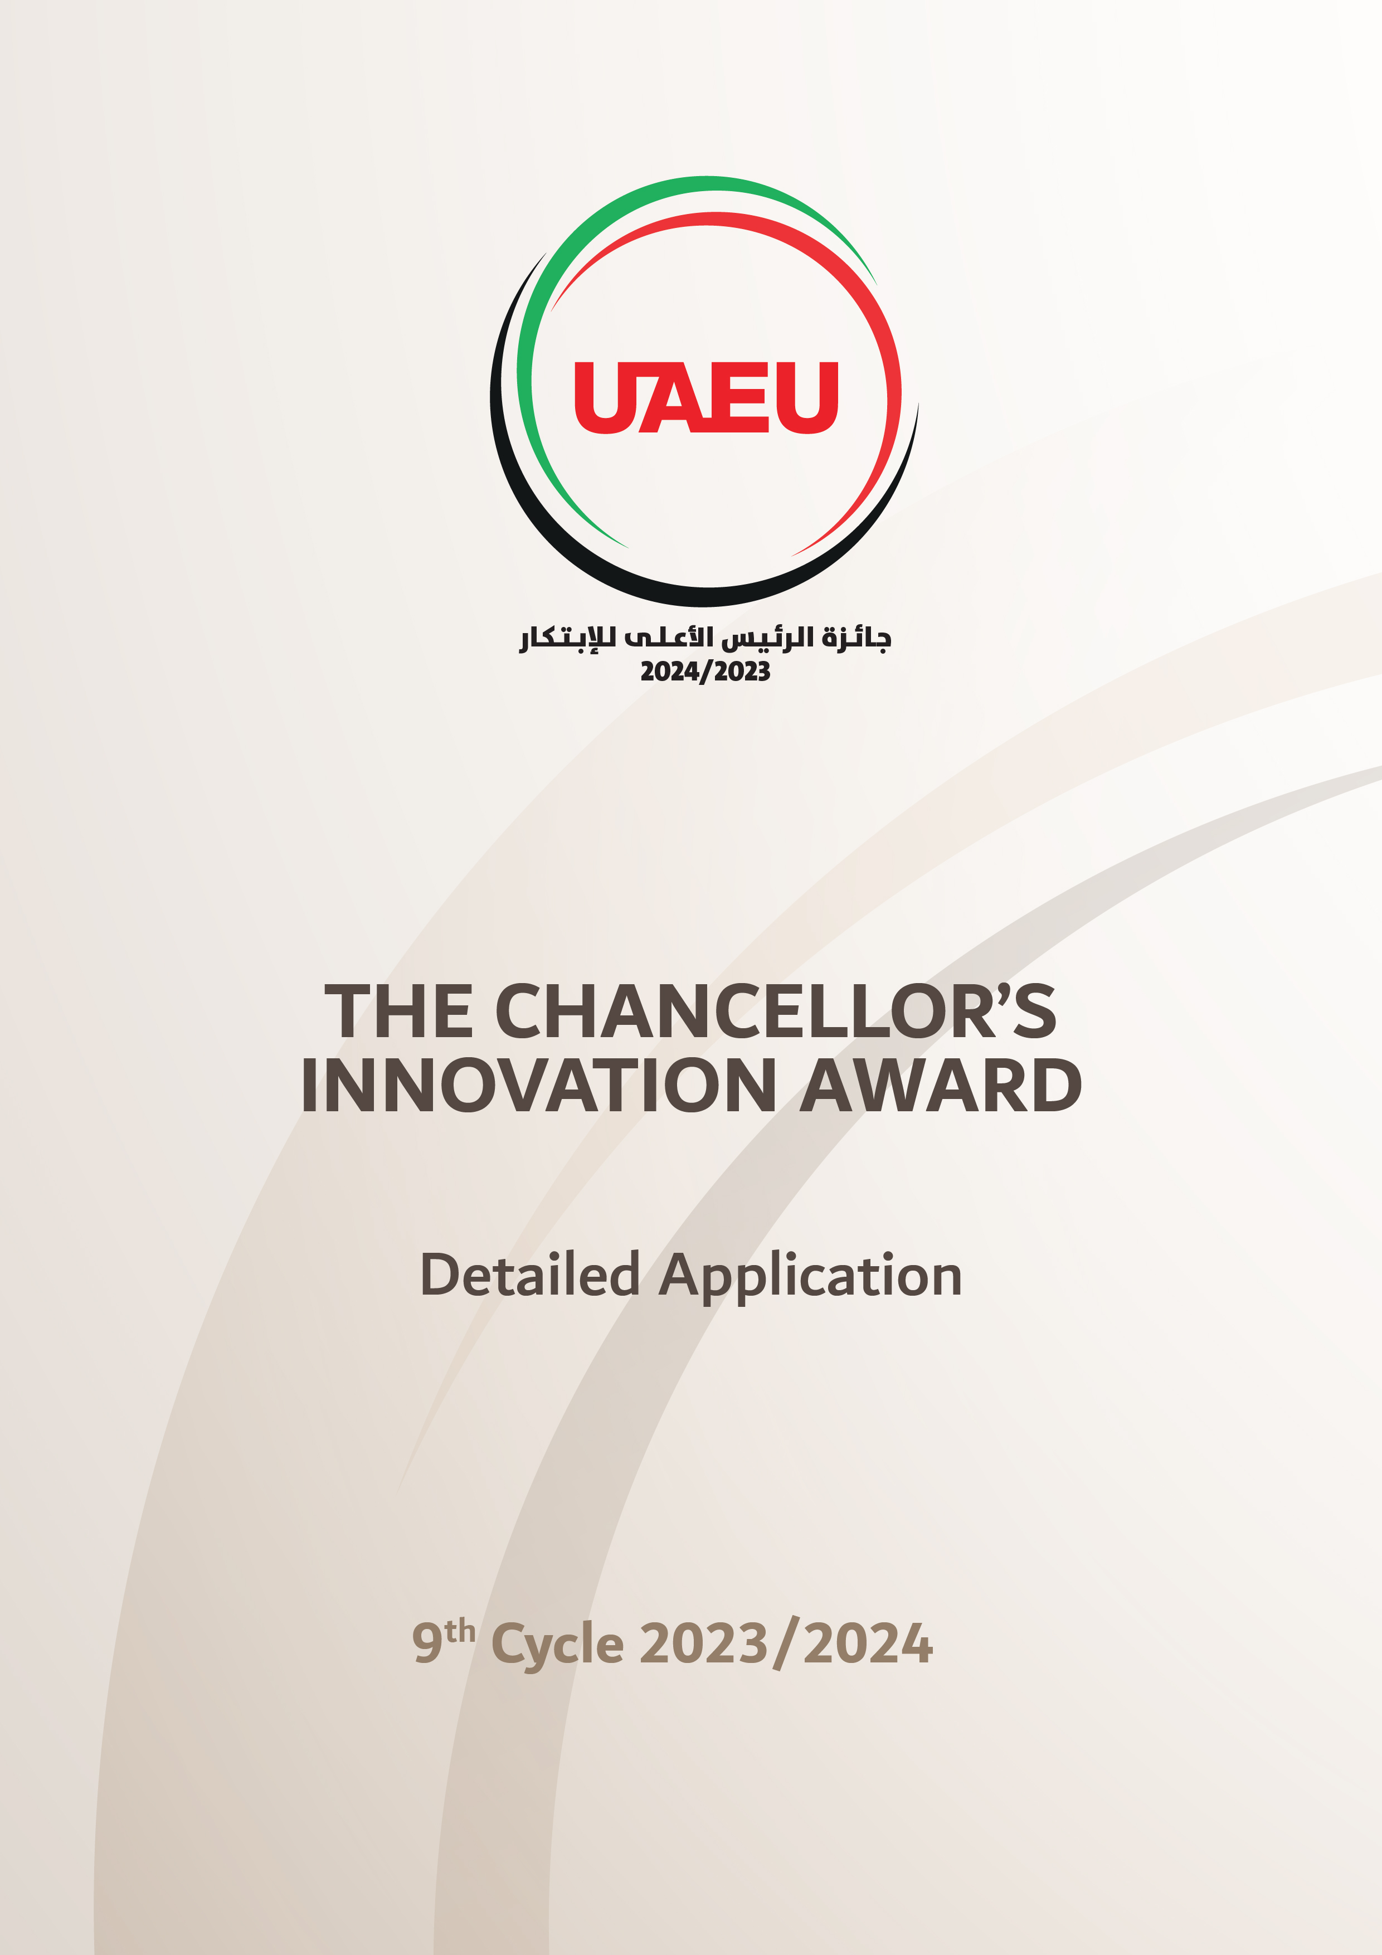

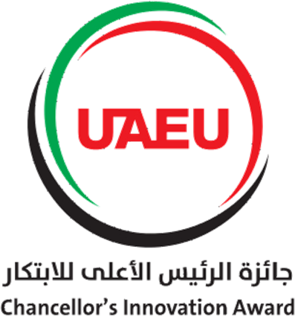

Proposal Title

Competition Area  (Select Only One) | Category  (Select Only One)
1. Climate Change and Environmental Sustainability; 2. Renewable Energy; 3. Water and Food  Security; 4. Health and Medical Science; 5. Education and Lifelong Learning; 6. Space Science;  7. Mobility and Urban Development; 8. Technology and Cyber Security; 9. Social, Administrative and Economic Growth | Faculty;  Employees; Students

Application ID# CIA000000000000

The Ninth Cycle - 2023/2024

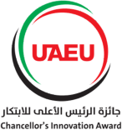

Application Review and Evaluation
Application will undergo subject matter peer review process according to the following criteria.
- Degree of Innovation: Originality, novelty, and creativity. Technical innovation and patentability.
- Usefulness and Value of the Idea: The application must have technical feasibility, effectiveness and be economical.
- Potential for Sustainability and Scale: Innovative solution can be sustained, scalable and have significant impact on the areas of interest in the UAE.
- Completeness and Plagiarism Statement: Quality and organization of the application materials.

Important Notes:
- Published and/or patented work before 31 December 2023, similar to the subject matter of the application will be excluded.
- If the subject matter of the application is not related to the selected competition area will be excluded.
3) Applicants should not refer to their names, jobs, and scientific department, whether in
text, image, video, or other means. In case of necessary applicants can use montage or shadow.

Guidelines for Completing Application Form

Executive Summary: (Maximum 300 words):
The Executive Summary should be written in lay language that a non-specialist can understand. Briefly describe the nature of the work to be conducted. Indicate why is this work is important, and how the UAE will benefit.

Keywords: (3-5 words)
Novelty Statement: (Maximum 1 page)
Describe the main objectives of your idea. Demonstrate the originality and creativity of your idea. Show that the idea is technically innovative and patentable?

Usefulness and Value of Idea: (Maximum 1 page)
Does the proposal have technical feasibility? Is there a need for the proposed solution and how will it meet that need? Is the proposed solution effective, economical, etc.?

Potential for Sustainability and Scalability: (Maximum 1 page)
Does this proposal have the likeliness to be sustainable and have significant, and long-lasting impact on the areas of interest in the UAE? Does this proposal scalable? Do you think that it is implementable at scale within the next 12 months?

Background and Motivation: (Maximum 5 pages)
This section describes the background and the state-of-the-art of current work. This section should address the following questions.
- What work has already been done that is relevant to your proposed idea? Give a brief survey with appropriate citations.
- Survey of existing solutions and their limitations.
- What this application will address and why is it important?

Methodology and Framework: (Maximum 10 pages)
Describe the research methodologies to be used, stressing the innovative elements. This section will vary depending on the type of proposed idea (field research, laboratory study, computer study, data collection procedures, proposed analytic methods, and statistical tools used). Describe the techniques you will use in sufficient details to allow the reviewer to judge this work. Provide diagrams, charts, and illustrations that you deem appropriate. Explain any limitations that your innovative idea/solution might have in terms of the reliability and applicability. Provide sufficient information on the tasks to be conducted and the time schedule to complete this work.

References.
List the articles, books, and websites that you have cited in your detailed proposal.

