Waffles Recipe
Menu
- Home
- About
- Gallery (folder images use the zip file small.zip and big.zip)
- Contact us(can be any with location map)
Pages
Home Page:
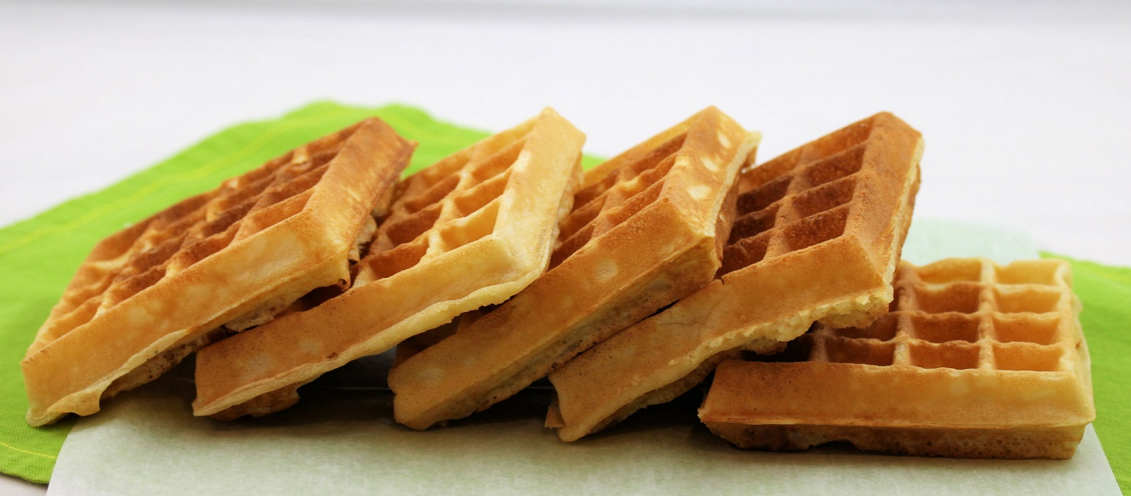
A waffle is a leavened batter or dough cooked between two plates, patterned to give a characteristic size, shape and surface impression. There are many variations based on the type of waffle iron and recipe used

About Page:
Waffles are preceded, in the early Middle Ages, around the period of the 9th–10th centuries, with the simultaneous emergence of fer à hosties / hostieijzers (communion wafer irons) and moule à oublies (wafer irons). While the communion wafer irons typically depicted imagery of Jesus and his crucifixion, the moule à oublies featured more trivial Biblical scenes or simple, emblematic designs.^{[8]} The format of the iron itself was almost always round and considerably larger than those used for communion.
The oublie was, in its basic form, composed only of grain flour and water – just as was the communion wafer.^{[12]} It took until the 11th century, as a product of The Crusades bringing new culinary ingredients to Western Europe, for flavorings such as orange blossom water to be added to the oublies; however, locally sourced honey and other flavorings may have already been in use before that time.
Oublies, not formally named as such until ca. 1200, spread throughout northwestern continental Europe, eventually leading to the formation of the oublieurs guild in 1270. These oublieurs/obloyers were responsible for not only producing the oublies but also for a number of other contemporaneous and subsequent pâtisseries légères (light pastries), including the waffles that were soon to arise

