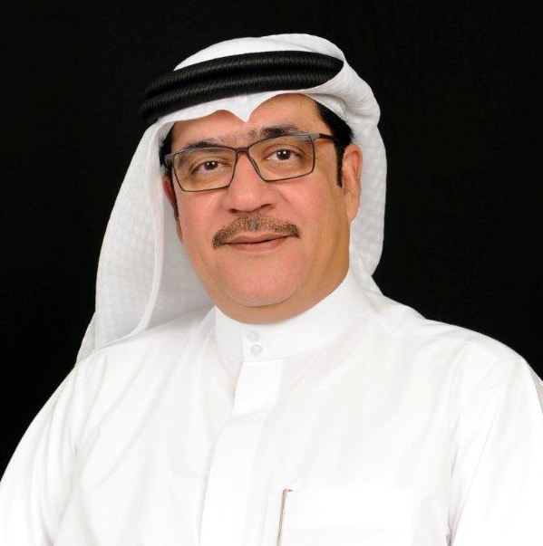


Salah AbdulRahman Amiri
Asst. Director General for Environmental & public Health services sector
Dubai municipality

Salah Amiri is a Mechanical Engineer with 30 years of experience in Dubai municipality.
He started his experience as an engineer till he became director of public transport department, for 12 years then transferred to be the director of Dubai central laboratory Dep. For six years. and after that promoted to assistant director for environmental and public health for the last 8 years dealing mainly with the infrastructure of sewerage, drainage and irrigation in emirate of Dubai, Greenery and landscape, cleaning and waste management, plus public health services as well .

