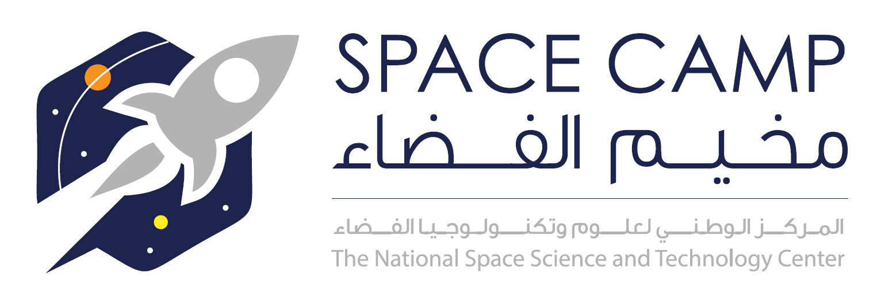

NSSTC First Space Summer Camp
July 8 - 12, 2018
Science and Innovation Park, UAE University, AlAin, UAE

This main objective of this summer camp is to excite young minds and inspire future scientists toward future science, technology, engineering, and mathematics (STEM). Encourage students to be interested in space.

Target audience
Group one (10 – 14 years old): 30 students
Group two (15 – 18 years old): 30 students
Only 60 seats available

Agenda
8th JULY | Group One (10-14) | Group Two (15-18)
9:00 – 9:30:00 am | Registration
9:30 – 9:40 am | Welcome
9:40 – 10:00 am | Introduction to space
10:00 – 10:20 am | Introduction to Astrophysics
10:40 am – 11:00 am | Building things that goes to space
11:00 am – 11:30 am | EMM mission
11:30 am – 12:00 | UAE Astronaut Program
12:00 - 1:00 pm | Break
1:00 – 2:00 pm | Random Activities
9TH JULY | Group One (10-14) | Group Two (15-18)
9:00 am – 12:00 pm | Microbit | Spacecraft Design
12:00 - 1:00 pm | Break
1:00 – 2:00 pm | Random Activities
10TH JULY | Group One (10-14) | Group Two (15-18)
9:00 am – 12:00 pm | Basics of Telescopes | Microbit
12:00 - 1:00 pm | Break
1:00 – 2:00 pm | Random Activities
11TH JULY | Group One (10-14) | Group Two (15-18)
9:00 am – 12:00 pm | Little bits | Android app)
12:00 - 1:00 pm | Break
1:00 – 2:00 pm | Random Activities
12TH JULY | Group One (10-14) | Group Two (15-18)
9:00 am – 12:00 pm | Water Rockets | Water Rockets
12:00 - 1:00 pm | Break
1:00 – 2:00 pm | Water Rocket Launch
2:00 – 3:00 pm | Ending Ceremony

